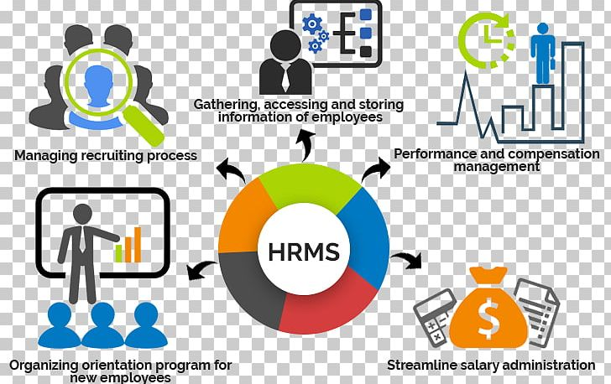

Overview

HR Management Software.

HRMS is abbreviated as Human Resource Management Software or a Human Resource Management System that helps HR professionals to automate their repetitive tasks in the HR workflows such as collecting and storing resumes, parsing resumes, saving candidates to the talent pool, automating job postings, providing employee self-service portal. An HRMS is also commonly described as a tool used to attract, engage, and delight employees throughout the employee life-cycle.

DESIGN & DEVELOPMENT TOOLS

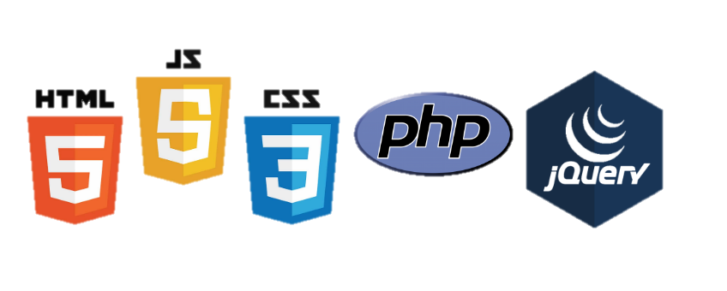


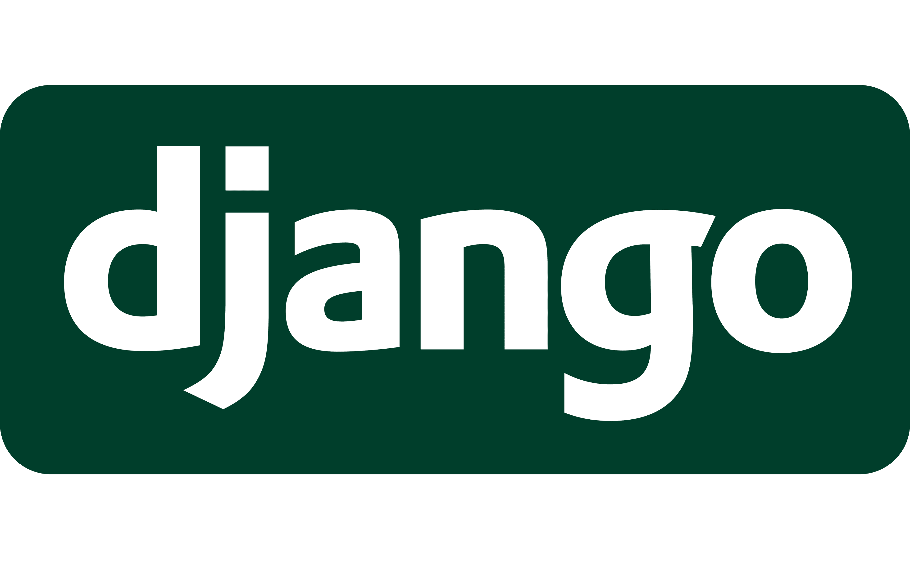
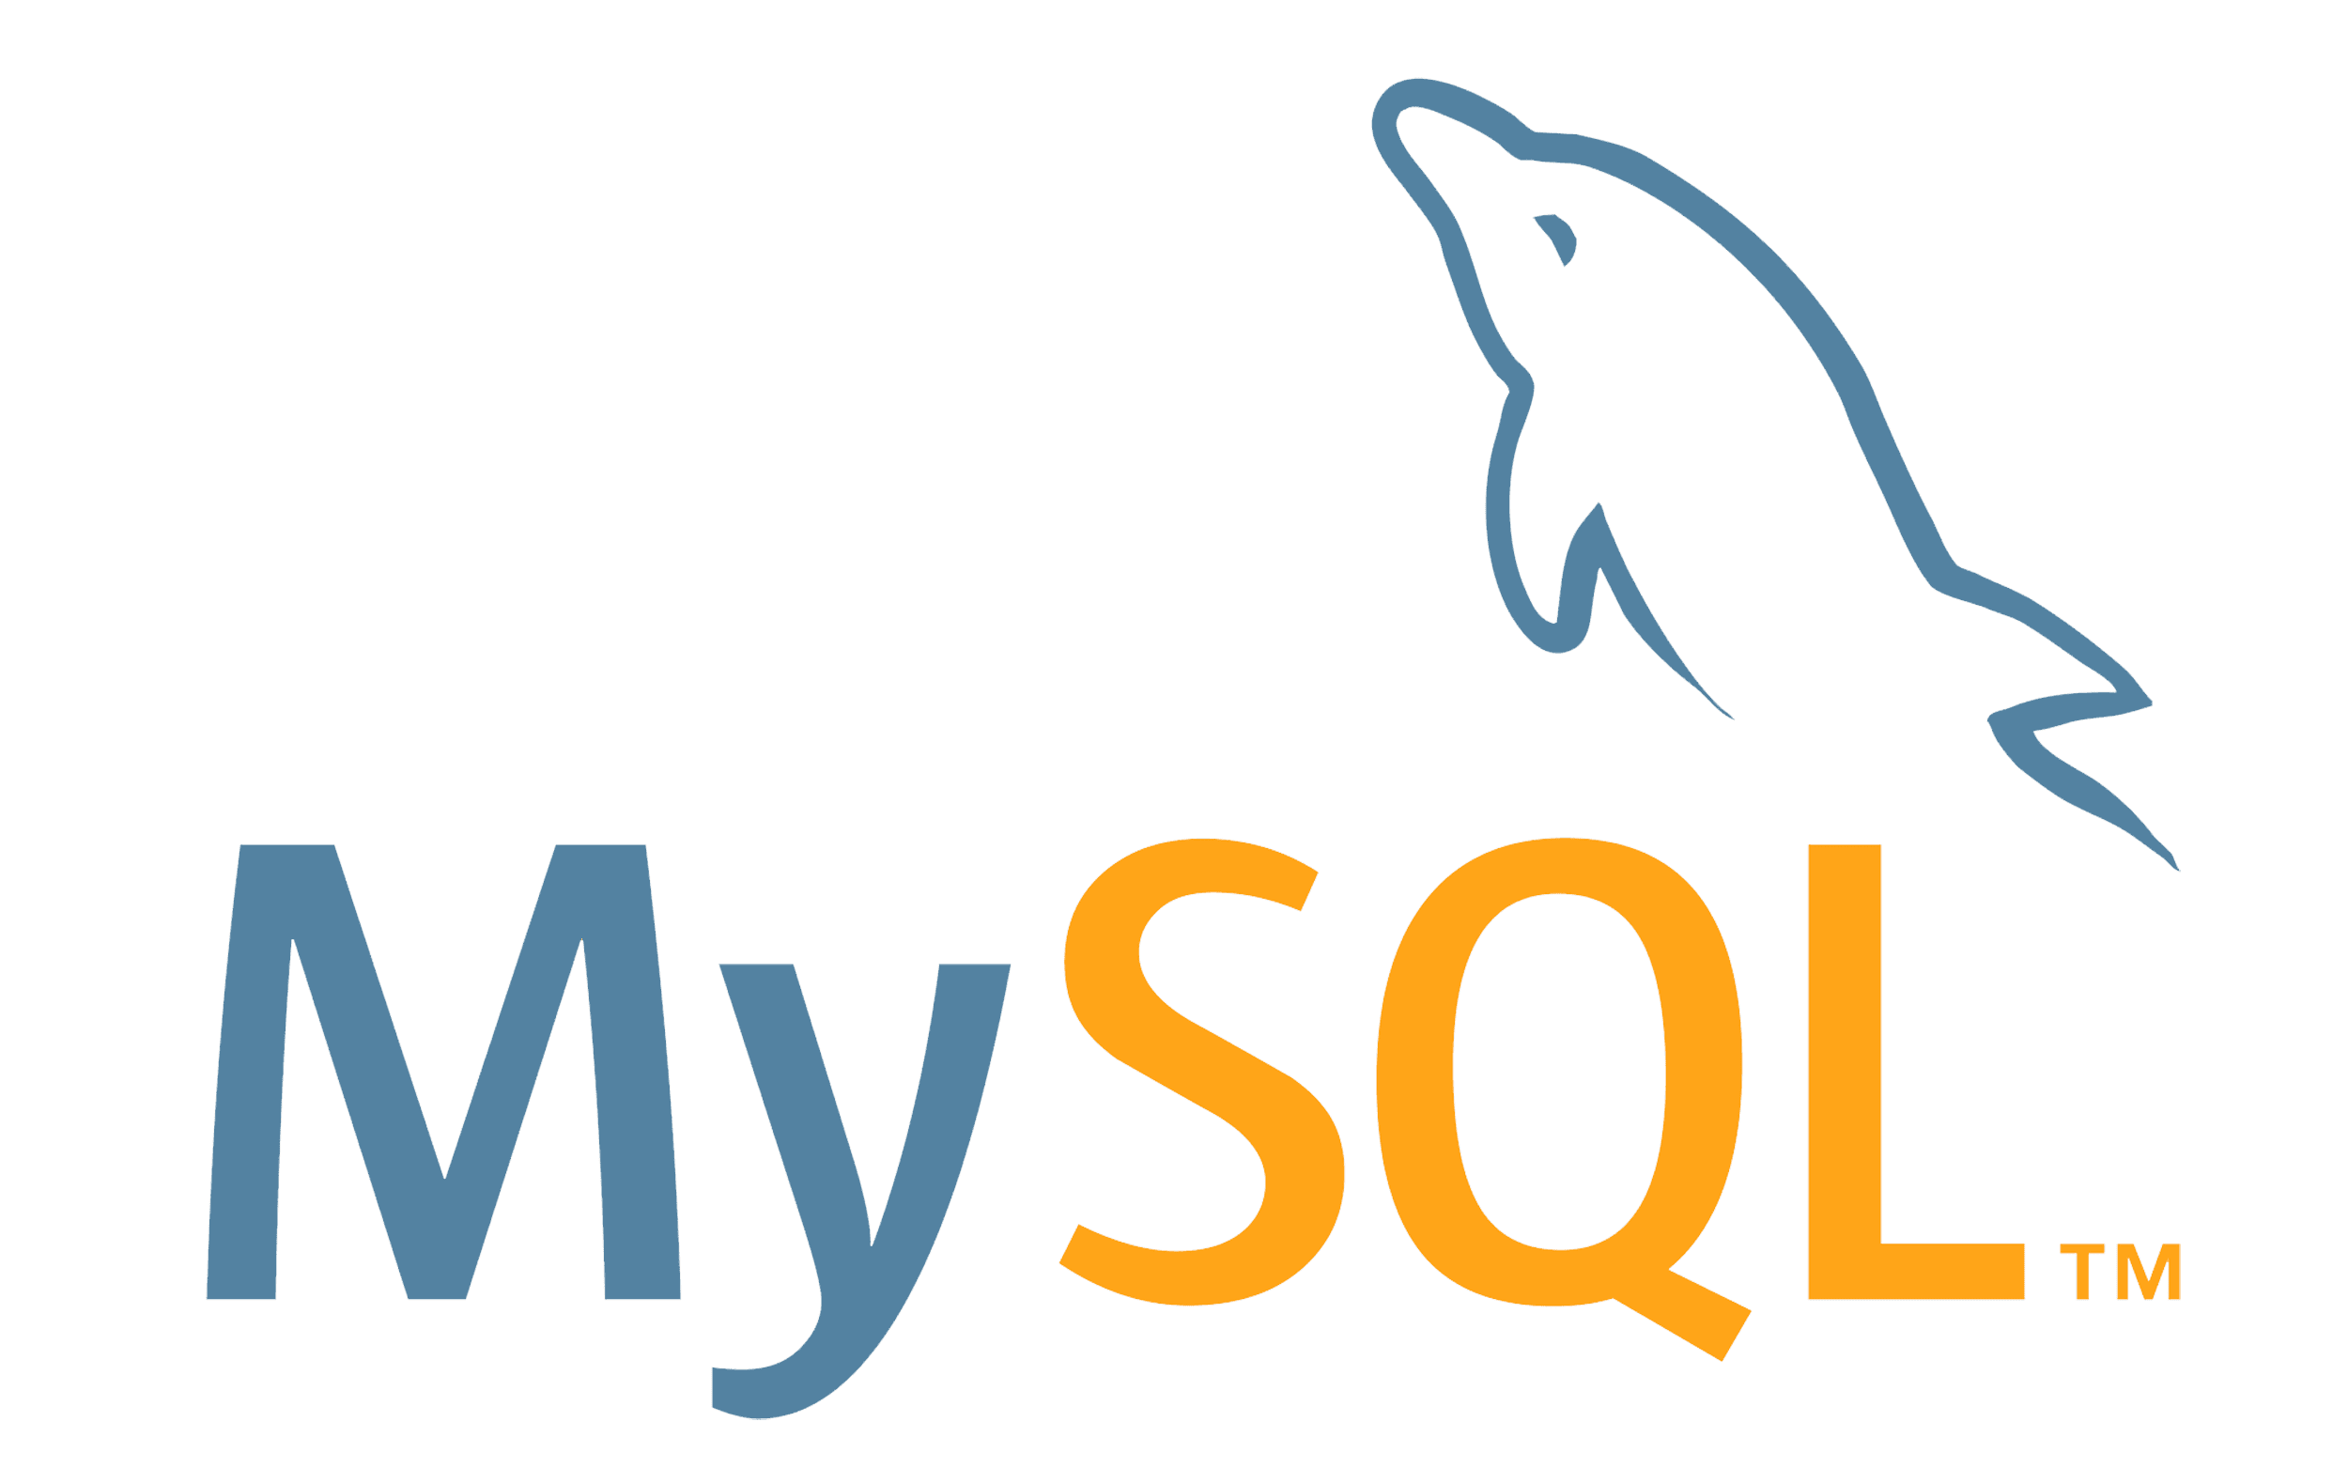

SL NO | ITEMS | DESCRIPTION
1 | Design | Bootstrap (Bootstrap is the most popular HTML, CSS, and JavaScript framework for developing responsive, mobile-first websites)
2 | Programming Language | Python (Python is a high-level, general-purpose programming language)
3 | Database | MySQL (MySQL is an open-source relational database management system (RDBMS))
4 | Script | JavaScript, jQuery, Ajax

BASIC FETURES & MODULES


- Authentication
  - User (Registration, Edit, Delete, List, Search, all users Pdf & excel download)
  - User Roles & Permission (Add, Edit, Delete)
  - User Login
  - User log history track with IP
  - Forgot password, Password Reset with Email link
  - User Profile Dashboard
  - User can update his profile information into dashboard

- Employee
  - Employee (Registration, Edit, List, Search, all employee’s history pdf & excel download)
  - Leave Settings (annual, sick, hospitalization, maternity, paternity, lop)
  - Employee Leaves
  - Admin approves leave
  - Leave Setting
  - Holidays settings
  - Attendance
  - Timesheet per project (add, edit, list)
  - Departments (add, edit, list, delete)
  - Designation (add, edit, list, delete)
  - Shift & Schedule (add, edit, list, delete)
  - Daily Scheduling
  - Over Time (add, edit, list, delete)
- Clients
  - Client (add, edit, list, delete)
  - Client login permission
  - Client profile for project update
  - Client can update his personal information

- Projects
  - Project (add, edit, list)
  - Project Task (add, edit, list)
  - Task Board (add, edit, list, delete)
  - Task Board (show task pending, progress, completed, Inprogress)
  - Project Lead List

- Tickets
  - Ticket Type (new, solved, open, pending)
  - Ticket (add, edit, list)
  - Ticket Board
  - Ticket Search

- Sales
  - Invoice (add, list, edit, search)
  - Payment invoices list
  - Payment invoice print
  - Expenses (add, edit, list, search)
  - Provident Fund (add, edit, list)
  - Taxes Type (add, edit, list, delete)

- Accounting
  - Accounting category type (add, edit, list, delete)
  - Budgets (add, edit, list)
  - Budget Expenses (add, edit, delete)
  - Budget Revenues (add, edit, delete)

- Payroll
  - Employee Salary (add, edit, list)
  - Generate Slip
  - Payroll Items (additions, overtime, deduction)
  - Additions (monthly remuneration, additional remuneration)
  - Overtime (normal day, public day, Rest Day)
  - Deduction (absent amount, advance, Unpaid leave)

- Policies
  - Policies (add, edit, list)

- Reports
  - Expense Report
  - Invoice Report
  - Payments Report
  - Projects Report
  - Task Report
  - User Report
  - Employee Report
  - Pay slip Report
  - Attendance Report
  - Leave Report
  - Daily Report

- Performance
  - Performance Indicator (Add, Edit, List)
  - Performance Review
  - Performance Appraisal
  - Training Type (add, edit, list)
  - Training list (add, edit, list)
  - Trainers (add, edit, list)
  - Promotion (add, edit, list)
  - Resignation (add, edit, list)
  - Employee Termination (add, edit, list)

- Assets
  - Assets (Add, Edit, List)

- Jobs
  - Jobs Dashboard
  - Manage Jobs
  - Manage Resumes
  - Shortlist Candidates
  - Interview Questions
  - Offer Approvals
  - Experience level
  - Candidates list
  - Schedule Timing
  - Aptitude Results

- Subscription
  - Subscription company (add, edit, list)

- Settings

- Pages
  - FAQ
  - Terms
  - Privacy Policy

